Module 3 – Vanilla JavaScript: Hello World Lab

# Lab Objectives

Create a basic web page that produces an alert in the browser

Create the Hello World web page with HTML and JavaScript separated into different files

Hello World

To create this application we must first create a file with the .html extension. In Visual Studio Code (VS Code) this is done by clicking **file -> new file** which will open a document temporarily called **untitled-1** then clicking **file -> save as** and entering **hello world.html**. The **Save as type** dropdown should also be changed to **HTML**.

1. 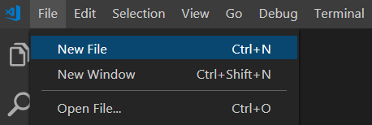

2.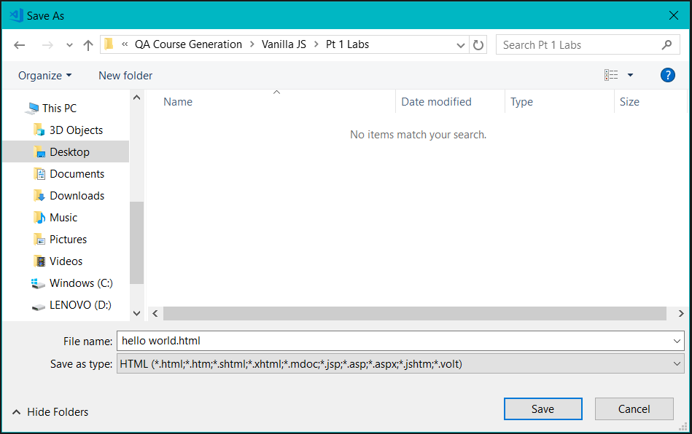

The next step in this process is to create the **<html>** tags on the page. This is done by adding **<html>** followed by **</html>.** Within these tags the body element must then be created by adding **<body>** and **</body>.** In between these tags two paragraph elements can then be added by inserting **<p>** followed by **</p>** twice and inserting some text in between the tags. The JavaScript to make the web page create an alert showing the text ‘Hello, World!’ can then be added, firstly the opening and closing tags of a script elements must be created by inserting **<script>** and **</script>**, following this we can now insert the required JavaScript between these tags. The JavaScript code to create an alert is as follows **window.alert(‘Hello, World!’)**. This will create a popup over our page containing the text ‘Hello, World!’. Your code should look as follows:

<html>

<body>

<p>First Paragraph</p>

<script>window.alert('Hello, World!')</script>

<p>Second Paragraph</p>

</body>

</html>

Best Practices and Improving our code

Whist having our JavaScript code in the same file as our HTML does work, this would not be good practice as it would not be done this way in the real world. This is because real world applications may have hundreds, if not thousands of lines of code and having all of this is one file will make it very difficult to manage and understand.

It is best practice to have this separated out into another file, to do this we need to create a new JavaScript file. This is done by repeating the process in the first example, however making the file extension .js, and choosing JavaScript as the file type in the dropdown menu.

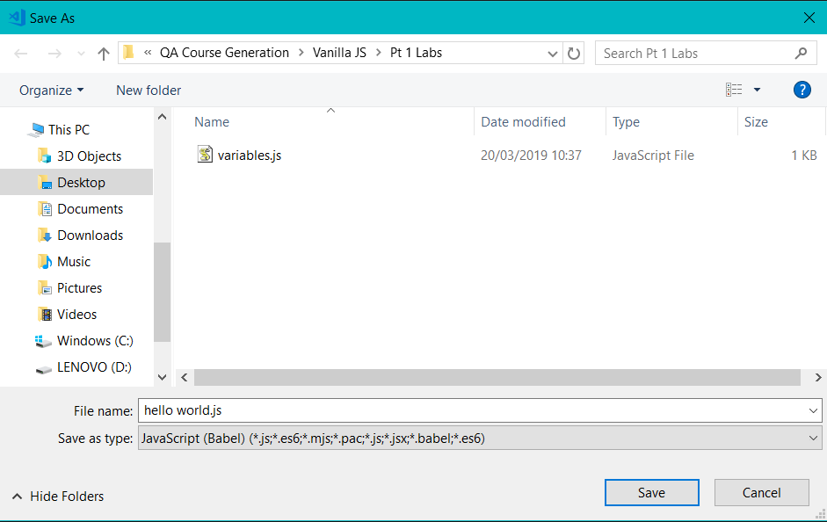

The next step is to insert our Javascript code into this file. This is the same line as is currently within the script tag.

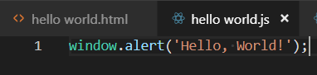

The next step is to add the src attribute into the script tag, and remove the code we have just inserted into the separate JavaScript file. The src attribute tells the script tag which file it should take its code from. In our case the file is called ‘hello world.js’ so this is what we should enter.

<html>

<body>

<p>First Paragraph</p>

<script src="hello world.js"></script>

<p>Second Paragraph</p>

</body>

</html>

If you now re-open ‘hello world.html’ the page should now be working in an identical way to it was previously, it is now simply easier to manage if more code is added.

Pay attention to how this is done as all labs following this will follow the same page structure.